Сумський державний університет

Кафедра

Прикладної математики та моделювання складних систем

Звіт з практичної роботи № 6

Дисципліна

Прикладне математичне моделювання

Варіант 8 (II)

Студентка: Пороскун Олена Олегівна

Викладач: Хоменко Олексій Віталійович

Суми, Сумська область

2020

**Практична робота 6 (варіант 2). Дослідження дворівневої моделі ІПД.**

**Завдання. Побудувати рис. 1-3. В аналітичній частині звіту записати основні розрахункові рівняння.**

Phase Diagram of Metals Fragmentation Modes at Severe Plastic Deformation

A.V. Khomenko[1], D.S. Troshchenko, K.P. Khomenko, I.O. Solonar

Sumy State University, 2, Rymskii Korsakov Str., 40007 Sumy, Ukraine

(Received 01 March 2016; revised manuscript received 25 May 2016; published online 22 August 2016)

Considering nonequilibrium evolutional thermodynamics, the approach is developed permitting to describe the process of metal or alloy fragmentation during severe plastic deformation. As a result of an explicit accounting of the main channels of energy dissipation, the basic Gibbs relation is obtained. The concept of state of strongly nonequilibrium system is introduced by means of the expansion of system's thermodynamic potential over independent variables. Using adiabatic approximation the nature of the basic nonequilibrium variables, the Landau-Khalatnikov equation and thermodynamic potential are determined. Carrying out the investigation of stability loss of steady-states of thermodynamic potential, the phase diagram of fragmentation modes of metallic materials is determined. It is shown that defects densities in formed limiting structures correspond to experimentally observed regularities.

**Keywords:** Grain Boundary, Dislocation, Phase Diagram, Limiting Structure, Internal Energy.

|  |  |
| --- | --- |
|  | PACS numbers: 05.70.Ln, 05.70.−a, 61.72.Mm, 64.30.Ef, 64.10.+h, 64.60.My, 83.10.–y |

introduction

The application of the methods of severe plastic deformation (SPD) permits to obtain the bulk metallic samples with almost pore-free submicrocrystal (SMC) or nanocrystal (NC) structure, which cannot be produced by ordinary thermomechanical processing. The obtained samples have high physical and mechanical properties, which are formed as a result of microstructure refining to submicro- or nanoscales with the large-angle grains boundaries (GBs) (up to 20°).

To achieve large strains in the fragmented material, the various methods are applied. Such methods as high pressure torsion (HPT) [1-4], equal channel angle extrusion (ECAE) [2], rolling, repetitive corrugation and straightening (RCS), 3D forging [5], twist extrusion (TE) [6], etc. The application of repeated shear plastic deformation at the expense of heavy load at rather low temperatures conditions is the base of SPD methods. It leads to the formation of structure with grain sizes about  and upward [1, 2, 5], which is rather important for modern nanotechnological process.

Recently, the construction of the theoretical models allowing to describe the processes of microstructure grinding of metal at SPD acquires significant importance. As a result, the special approach within nonequilibrium evolutional thermodynamics (NET) is developed [7-13]. It helps to establish unambiguously the course of nonequilibrium processes (heating and defect generation) and transformation nature of internal energy during material processing. Consideration of bounded multidimensional polynomial relationship for density of internal energy allows us to reflect unambiguously the nature of grains fragmentation and attendant processes of limiting structures formation under the influence of SPD.

The energy basics of approach

On the basis of the fundamental inequality, that combines the first and second laws of thermodynamics, the basic relation for density of internal energy was obtained previously in works [12-16]. This relation uniquely determines the course of power conversion during the material processing. Its expansion over the independent variables allows us to use the concept of the state of strongly nonequilibrium system.

As is well known, the processes taking place during SPD processing are quite complex since it cover all levels of structural defects. It is obvious that grain boundary and dislocation are the most important types of defects, because their evolution directly determines the fragmentation degree of solids. Therefore, let’s restrict consideration to two-defect model for modeling the processes of defect formation under SPD.

In this case, bounded polynomial relationship for density of internal energy is given by [12-17]:

* 1. 
  2. , (1)

where , , are some coefficients depending on the control parameter  (elastic strain). These coefficients are defined by following relationships:

* 1. , (2)
  2. , (3)
  3. , (4)

where  is a modulus of one-sided compression; ,  are the Lamé coefficients; , are the first and second invariants of elastic strain tensor;  is a positive constant characterizing the intensity of the defects production at tension () or the defects annihilation at compression (); ,  are the elastic constants caused by the defects existence;  expresses the process of defects annihilation at positive value  or means the defects production at negative value . Indexes values belong to the GBs and to the dislocations .

According to the elasticity theory [18] invariants of strain tensor are determined by the expressions:

* 1.  (5)
  2. 
  3.  (6)

The thermal channel of energy dissipation isn’t considered in this work. In case of dislocations, the power expansion of internal energy (1) is examined only up to the second power over their density [13].

It is important to note that value of plastic (accumulated) strain, in the considered theory, appears implicit in the form of the defect density (see the derivation of a generalized Gibbs relation in [12]).

Moreover, physical meaning of theory coefficients in (1)-(4) plays an important role in the definition of really observed process of fragmentation of metals or alloys at SPD. Selection technique of the basic parameters and determination of the explicit physical meaning of some of them are described in Refs. [12, 13]. According to the carried out analysis, the main set of parameters and coefficients is offered [12, 13, 17]

* 1. 
  2.  

Phase diagram of fragmentation modes

Based on fundamental energy potential for density of internal energy (1), the evolutionary equations are determined by following relations:

* 1.  (7)
  2.  (8)

Note that the basic relations (1)-(4) within approach of nonequilibrium evolutionary thermodynamics are obtained by L.S. Metlov in studies [12, 13, 17].

Considering the adiabatic approximation , we define the nature of evolution of the main variables  (). In this case, change of dislocations density follows the variation of GBs density in whole time interval. Taking  in Eq. (7) and carrying out the series of transformations (see derivation in [14, 15]), we obtain the Landau-Khalatnikov equation:

* 1. . (9)

Its explicit form looks like

* 1. .(10)

At the same time, the system is characterized by the thermodynamic potential

* 1.  (11)

coincided with relation (1).

Using a necessary condition of extremum existence (), we define stationary states of thermodynamic potential  (11). Putting  in Eq. (10), the cubic equation is obtained

* 1.  (12)

Its roots correspond to maximums of thermodynamic potential and to the stable states. Respectively, the minimums represent unstable states.

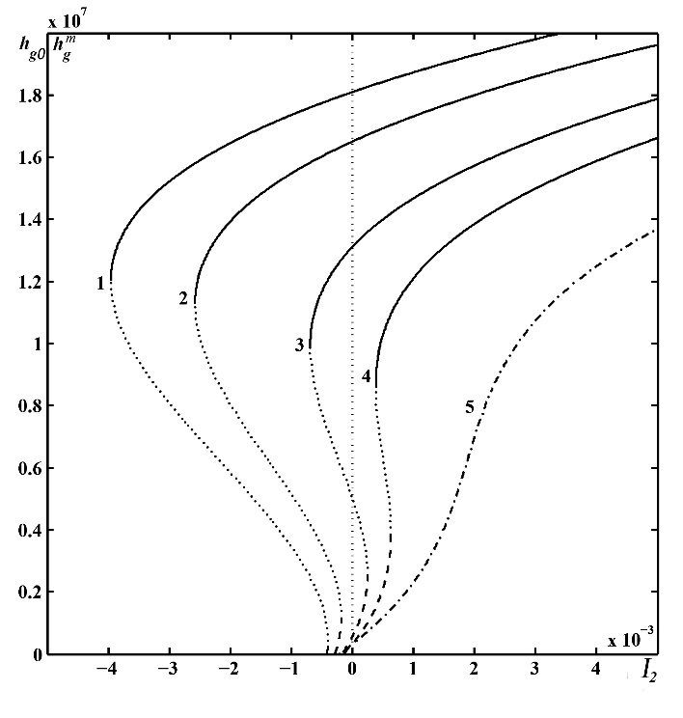

**Fig. 1** – Dependence of stationary states of the GBs density  on the second invariant of strain tensor . The curves 1-5 correspond to the values 

Dependence of stationary GBs density (i.e. solutions of Eq. (12)) on control parameter  at different values of the first invariant  is shown in Fig. 1. According to this graph, Eq. (12) at compressive strain () has three solutions. These roots correspond to three steady-states of . Stable states are produced by dashed and solid segments of curves 1-4. Unstable states or minimums of  are represented accordingly by dotted parts. The first maximum of potential can realize for both zero () and nonzero values of GBs density, depending on values of the second invariants .

As is evident from Fig. 1, dashed sections of the curves 1-4 correspond to smaller stable states  (the big-grain polycrystal (BGPC)). Solid parts of the lines conform to bigger values  (the fine-grained structure (SMC or NC)). These steady-states are separated by unstable states  (dotted parts of the curves). At this stage, the process of fragmentation of metallic structure can begin to proceed only at the realization of transition from zero to nonzero maximums of thermodynamic potential . It happens when potential well, which separates steady-states, disappears at certain values of the control parameters.

In the case when metallic sample has fine-grained structure before the processing by SPD methods, the formation of stationary states with higher dispersed structure, according to curve 4, becomes possible even at small values of  (equilibrium state of , which close to nonzero extremum, is realized). However, the inverse process of recrystallization (curves 1-3), which often happens during the material processing [1, 5, 19], is possible at the occurrence of negative shear strain. Considering the process of deformation in general, the curves 1-4 are characterized by similar behavior. However, the case described by curve 4 differs a little, since simultaneous coexistence of zero and nonzero maximums of potential is impossible.

Let’s carry out the investigation of steady-states  (solutions of Eq. (12)) stability loss, which allows us to establish a direct connection between the applied strain  and the formation of SMC or NC structures. Putting  in Eq. (12) and writing down the condition of zero maximum formation, we define a critical value for second invariant

* 1. 
  2.  (13)

Relation (13) is represented by curve 1 in Fig. 2. This curve reflects the critical value of realization of the first maximum of  at . Obviously those values of the first invariant  are arguments for Eq. (12), therefore all curves in Fig. 1 originate in different points. The critical values of other solutions of steady-state equation (12) are found with the help of necessary condition of extremums existence. Solving the cubic equation, we obtain critical stationary relation for GBs density, which separates minimum and nonzero maximums of thermodynamic potential  [15]. As a result, critical expressions for second invariant determine the phase diagram of metals or alloys fragmentation regimes shown in Fig. 2. As can be seen, in phase diagram four domains of fragmentation of metallic samples are formed. At the same time, the behavior of thermodynamic potential  (11) in each domain is presented by corresponding curves in Fig. 3.

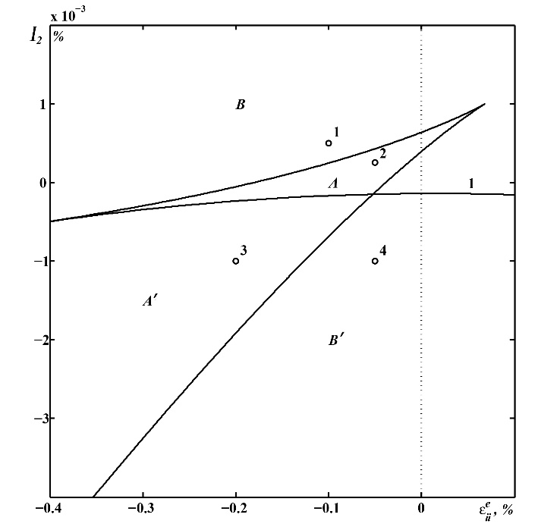

**Fig. 2**– Phase diagram of fragmentation regimes

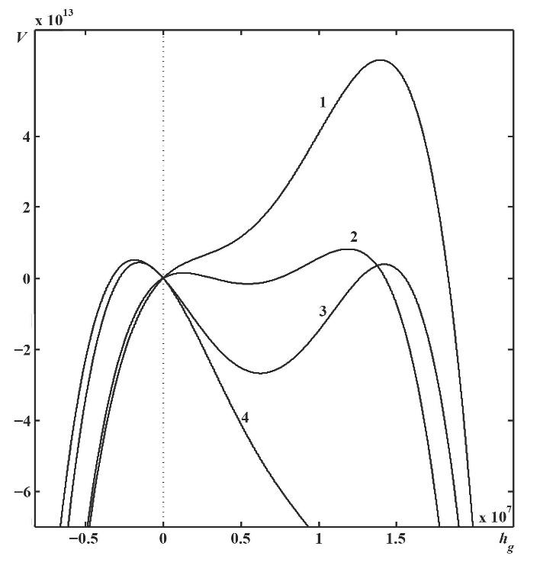

**Fig. 3**– Dependence of thermodynamic potential  (11) on GBs density. The curves 1-4 are constructed for the values of the both invariants  and  corresponding to the points 1-4 in Fig. 2

Two nonzero maximums of thermodynamic potential  are formed (curve 2 in Fig. 3), considering the elastic strain from the domain . There is a formation of two limiting structures with large grains (state determined by the first maximum of potential) and finer SMC or NC structure (i.e. second maximum). Looking at domain , a significant difference from the domain  is that the first maximum of potential becomes zero (curve 3 in Fig. 3). In this case, metallic sample is considered as a single crystal or BGPC.

It is noteworthy that transition from the first to second limiting structure, which is characterized by crystallites existence with the different sizes, can happens directly during SPD [2, 4, 19]. When processing is complete, it is supposed that the sample is formed, and further fragmentation of grain structure isn't carried out. Besides, the processing conditions (deformation rate, temperature and applied pressure etc.) are an important factor for producing sample with SMC or NC grain structure during SPD. Therefore, it should be assumed that obtained crystallite sizes are limiting only for certain deformation conditions.

Considering large strain in the domain  in phase diagram (Fig. 2), one limiting structure is realized (curve 1 in Fig. 3). Only one zero steady-state, corresponding to single crystal or BGPC, is formed at application of small strain from the domain  in Fig. 2. In this case, the behavior of thermodynamic potential is characterized by curve 4 in Fig. 3. As is seen, the stationary state forms in negative range analogically to curve 3. However, it is devoid of physical sense. Therefore, we suppose that after reaching zero value the density of GBs stops to decrease and considered system exists in the mode . Thus, the phase diagram (Fig. 2) permits to present the possible schemes of system behavior and can play an important role in terms of the technical applications [1-5, 19-21].

Conclusioins

The process of solids fragmentation within nonequilibrium evolutional thermodynamics has been investigated. Combination of the first and second laws of thermodynamics allows us to obtain basic thermodynamic identity for density of internal energy, which defines unambiguously the nature of energy conversion during material processing by SPD. The introduced variables reflect the specifics of structural defects generation and the accompanying processes of formation of limiting structure under the SPD effect.

The stationary states and phase diagram in approximation of a two-defect model are constructed. The conditions of generation of various types of limiting structures under the SPD are set. Depicted limiting structures meet the maximums of the thermodynamic potential. The defects densities of these steady-states correspond to experimentally observed regularities.

Aknowledgements

The work was executed under support of the Ministry of Education and Science of Ukraine within the framework of the project “Nonequilibrium thermodynamics of metals fragmentation and friction of spatially nonhomogeneous boundary lubricants between surfaces with nanodimensional irregularities” (No. 0115U000692). We are grateful to Prof. L.S. Metlov for valuable comments.

REFERENCES

R.K. Islamgaliev, K.M. Nesterov, R.Z. Valiev, *Vestnik UGATU* **17** No4 (57), 81 (2013).

I.G. Brodova, *Journal of SibFU. Engineering and Technologies* **8** No4, 519 (2015).

A.A. Mazilkin, B.B. Straumal, S.G. Protasova, O.A. Kogtenkova, R.Z. Valiev, *Phys. Solid State* **49** No5, 868 (2007).

B.B. Straumal, S.G. Protasova, A.A. Mazilkin, O.A. Kogtenkova, L. Kurmanaeva, B. Baretzky, G. Schütz, A. Korneva, P. Zicęba, *Mater. Lett.* **98**, 217 (2013).

S.N. Sergeev, I.M. Safarov, A.V. Korznikov, R.M. Galeyev, S.V. Gladkovsky, E.M. Borodin, *Letters on Materials* **2** No3, 117 (2012).

Ya.E. Beygelzimer, V.N. Varyukhin, D.V. Orlov, S.G. Synkov, *Twist extrusion − process of deformation accumulation* (Donetsk: TEAN: 2003).

A.V. Khomenko, I.A. Lyashenko, *J. Phys. Stud.* **11** No3, 268 (2007).

A.V. Khomenko, I.A. Lyashenko, *Tech. Phys*. **50**, 1408 (2005).

A.I. Olemskoi, A.V. Khomenko, *Phys. Rev. E* **63**, 036116 (2001).

A.V. Khomenko, N.V. Prodanov, *Carbon* **48**, 1234 (2010).

A.V. Khomenko, I.A. Lyashenko, *Condens. Matter Phys.* **9** No4(48), 695 (2006).

L.S. Metlov, *Phys. Rev. E* **90**, 022124 (2014).

L.S. Metlov, *Nonequilibrium evolution thermodynamics and its applications* (Donetsk: Noulidge: 2014).

A.V. Khomenko, D.S. Troshchenko, L.S. Metlov, *Condens. Matt. Phys.* **18**, 33004 (2015).

A.V. Khomenko, D.S. Troshchenko, D.V. Boyko, M.V. Zaharov, *J. Nano- Electron. Phys.* **7**, 01039 (2015).

A.V. Khomenko, N.V. Prodanov, K.P. Khomenko, D.S. Troshchenko, *J. Nano- Electron. Phys.* **6** No1, 01012 (2014).

L.S. Metlov, V.N. Varyukhin, *Fiz. Tekh. Vysok. Davlenii* **20**, 7 (2012).

A.G. Gorshkov, E.I. Starovoytov, D.V. Tarlakovsky, *Theory of elasticity and plasticity* (Moscow: Fizmatlit: 2002).

Yu.V. Khlebnikova, L.Yu. Egorova, V.P. Pilyugin, T.R. Suaridze, A.M. Patselov, *Tech. Phys.* **60** No7, 1005 (2015).

A.D. Pogrebnjak, *J. Nanomater.* **2013**, 12 (2013).

A.D. Pogrebnjak, K.A. Dyadyura, O.P. Gaponova, *Metallofiz. Noveishie Tekhnol*. **37** No7, 899 (2015).

Коефіцієнти:





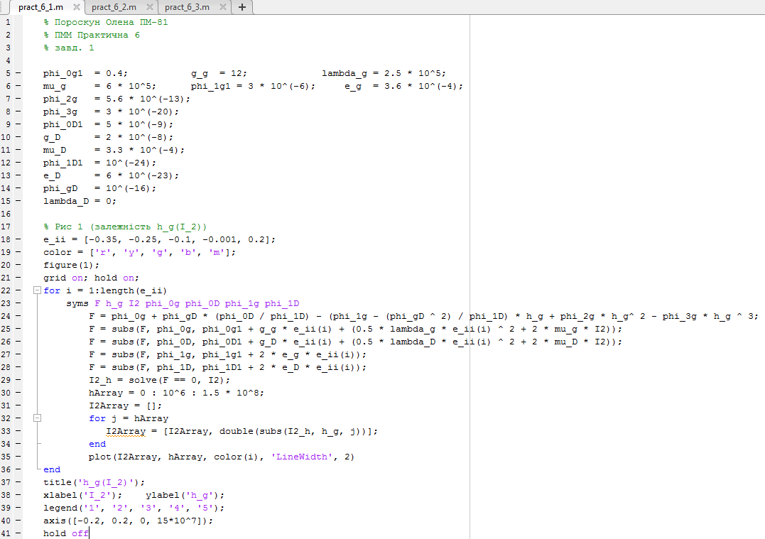

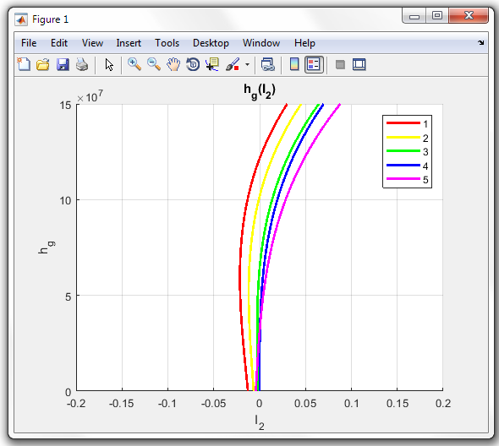

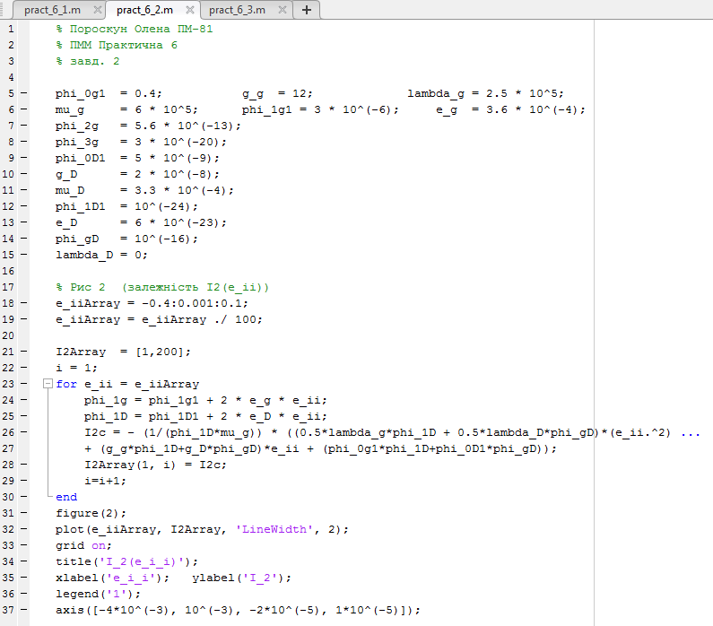

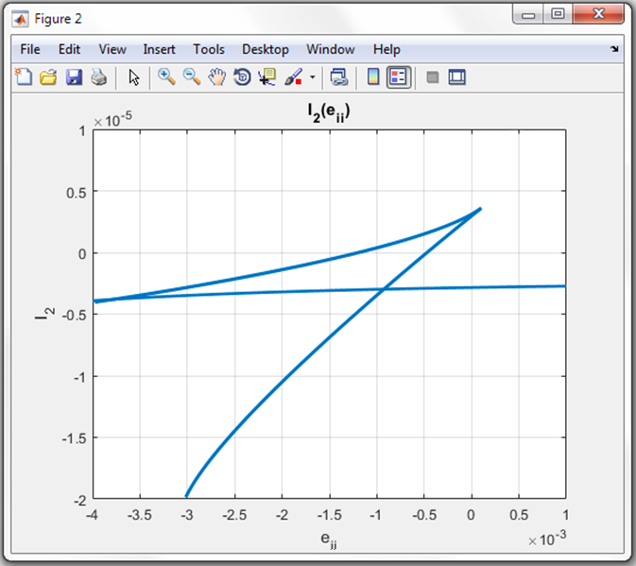

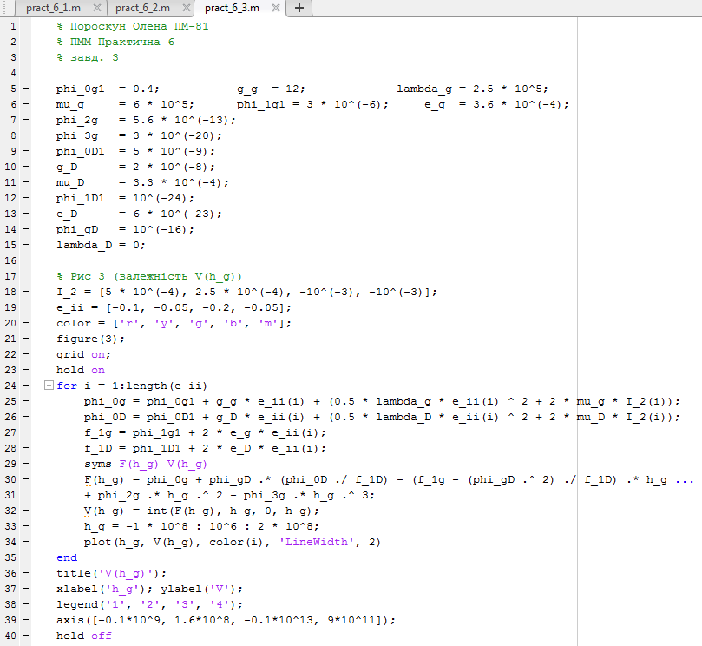

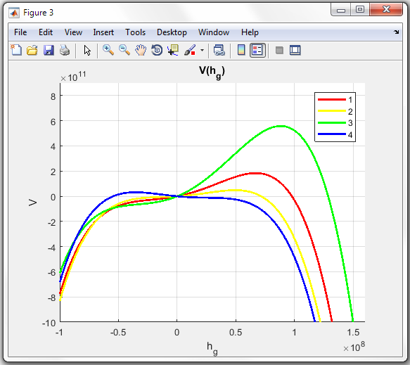

1. o.khomenko@mss.sumdu.edu.ua